HOLMFIRTH CONSERVATION GROUP

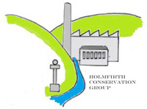

COMMITTEE

RACHEL HOGLEY - Parish Council Representative

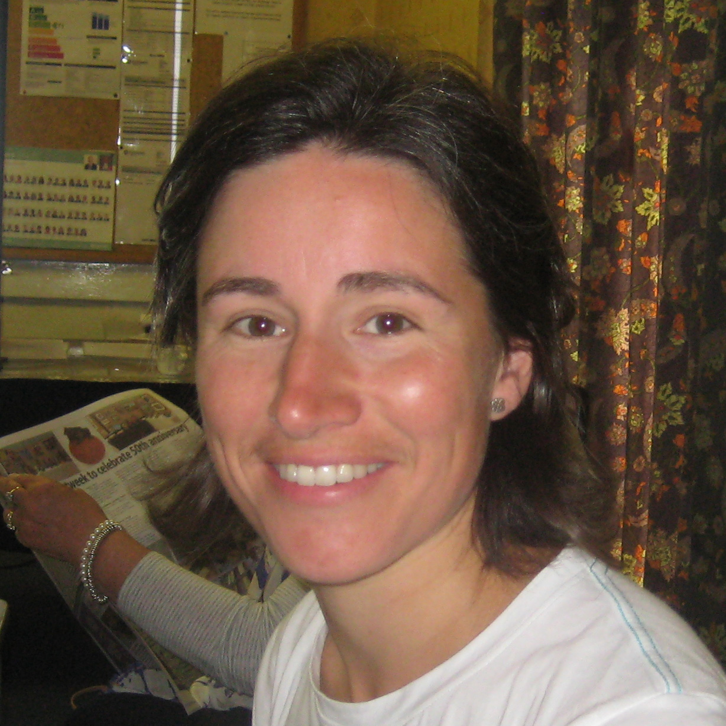

Rachel Hogley became the Holme Valley Parish Councillor for Holmfirth Central in 2015.  She has had a diverse career in the railway industry and civil service and whilst currently taking a career break to spend more time raising her three young children, she has committed herself to using her project management skills to help the town and wider valley flourish.  She is a passionate advocate of supporting local facilities and businesses and led the Holmfirth Christmas lights in 2015, now chairing a new Holmfirth Christmas Team, as well as coordinating the Upperthong Scarecrow Festival and various other local events and campaigns.  Rachel hopes she can support groups in working more effectively together for the benefit of our community and is keen to support HCG in making its appraisal and action plan a turning point in the future conservation and appearance of our beautiful town.

ANNE BACON - Chairperson

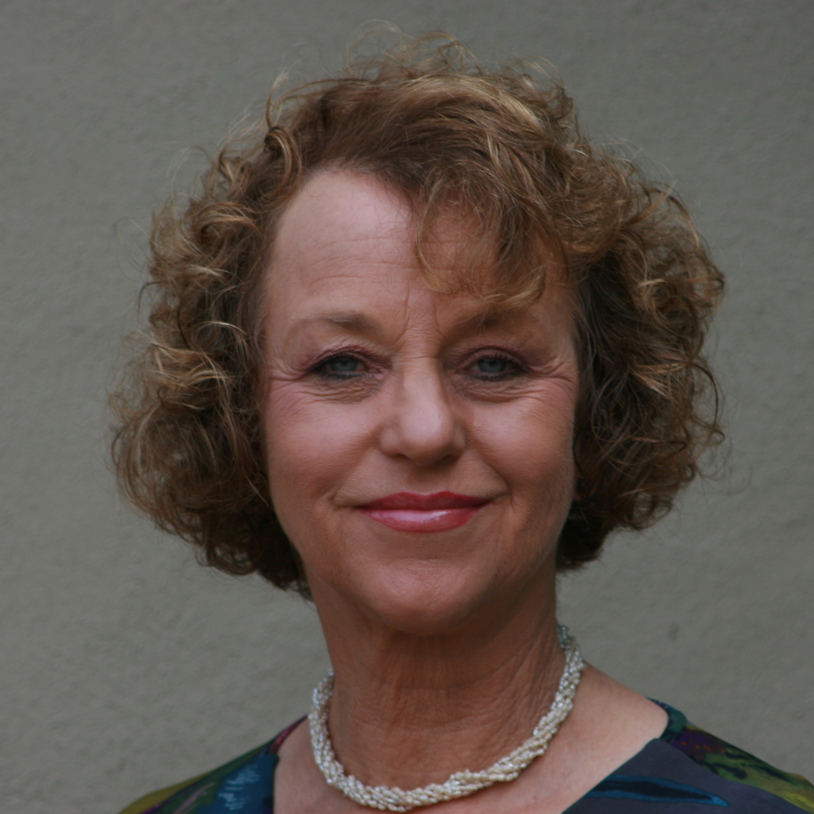

Anne Bacon has lived in the Holme Valley for 30 years and immediately fell in love with the landscape and the people. In an earlier life Anne worked as a volunteer for several years with vulnerable families and particularly with children under the age of 5. She retired from teaching eight years ago where she worked as the lead from 1990 to develop the use of computer and computer networks in teaching and learning. Anne is committed to community work and is a volunteer steward with the Holmfirth Film Festival and a volunteer member of the team for the Holmfirth Arts Festival. Anne was one of the founding members of HCG and represents the group on the Steering Group of the Neighbourhood Plan. As the hub of the Holme Valley, Holmfirth is the starting point for what Anne hopes will become a rolling programme of appraisal, throughout the small towns and villages of the Holme Valley.

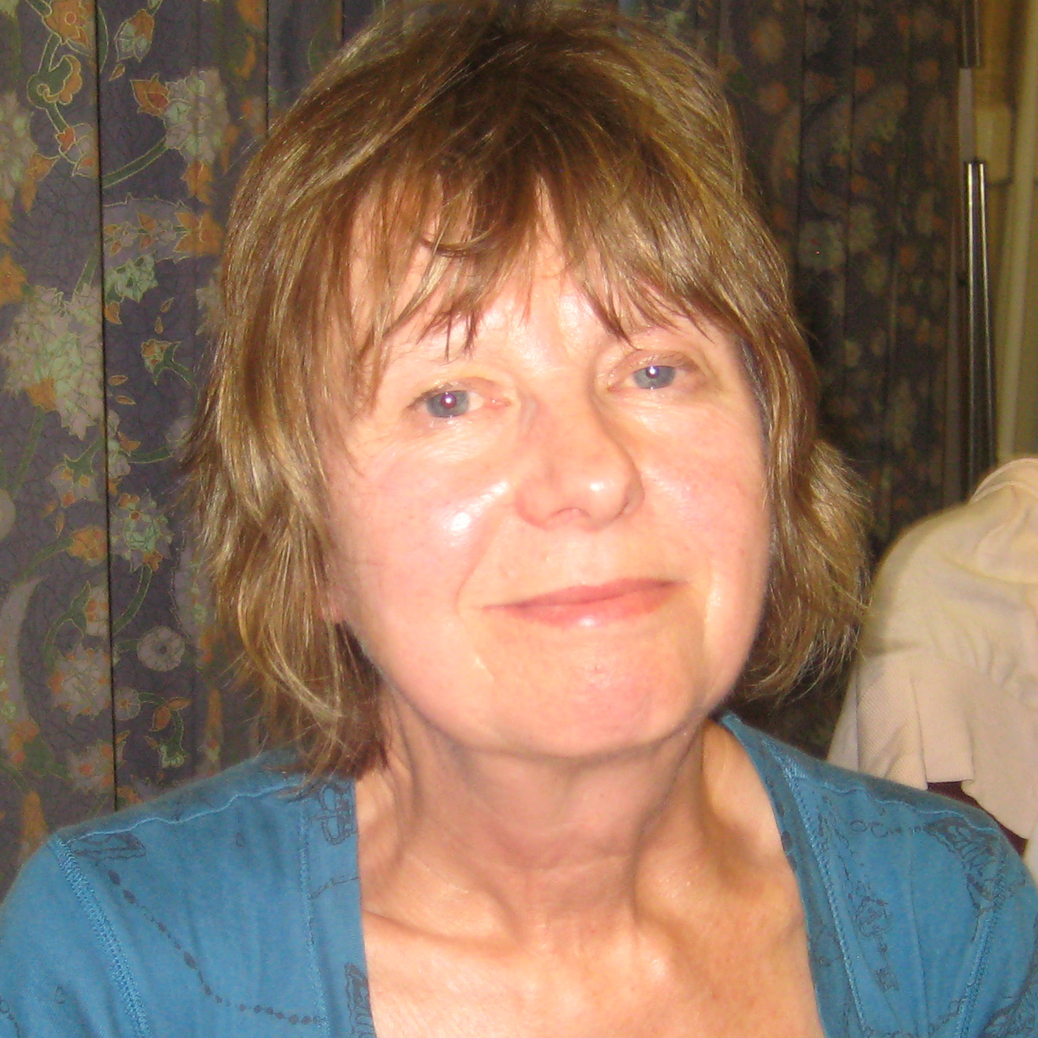

DEBORAH WYLES – CIO Secretary, Editorial Team, Chair Information Board Committee, Visitor Trails.

Deborah has lived in Holmfirth since 1998 and retired as a community dietician in the NHS eight years ago. Since then those community skills have been put to use locally in the form of involvement in the Friends of Cliff Rec- including co-writing a book on its history and liberating the HMS Hero plaque and finding the means to put the plaque on more public display. Other local history interests include helping to write the history of Holmfirth pubs and the Holmfirth history trail in conjunction with other members of the Civic Society local history group.

In addition she is the secretary of the Phoenix Women's Group and enjoys walking in and around this most lovely part of Yorkshire.

JON GREEN – Treasurer

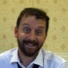

Jon was born in Chester and left school at 15 to work for Chester City Council in the Planning department. He became interested in architecture and left at 18 to follow a career in design.

Jon went to Leeds University and achieved a degree in Industrial design Engineering and, after a period of flux where he ran a restaurant in the Chester City Centre, entered the teaching profession working in various schools teaching design in Bournemouth. 10 years ago he moved back up north again and has worked with Special Needs children ever since as a teacher, firstly as an SEN Manager in a large Secondary School in Wakefield before moving jobs to Newsome High School.

Jon and his family have lived in Holmfirth for nearly 10 years now and love it. Until recently they thought that his link to the area was simply because it is a lovely place to live (of all the places “Up North” to move to it had to be Holmfirth; he felt naturally drawn to it). His brother has carried out work in depth on their family tree and, whereas they thought their family originated in Kildare in Ireland, it turns out that the family goes back to at least 1080 in West Yorkshire. They had members of the family as Knights, Sheriffs of Yorkshire, Sheriffs of Yorkshire, beheadings with heads displayed on the Micklegate in York! Due to family fallout his Grandad he didn't talk about his past so the whole situation was a mystery to them until 4 months ago. They were a very affluent family historically until Henry 7th removed all property from the family when he imprisoned their Great, Great, Great, (etc.), Grandfather for standing against him in an uprising.

Jon loves walking in this area, the housing, the history, the schools, and the quality of life. His 2 children are very involved in Southgate Theatre, Dancing, Drumming and both sing in Huddersfield Young Singers who will (hopefully) be singing at the Royal Albert Hall if they get through the finals of Music for Youth in which they sang in Birmingham last week.

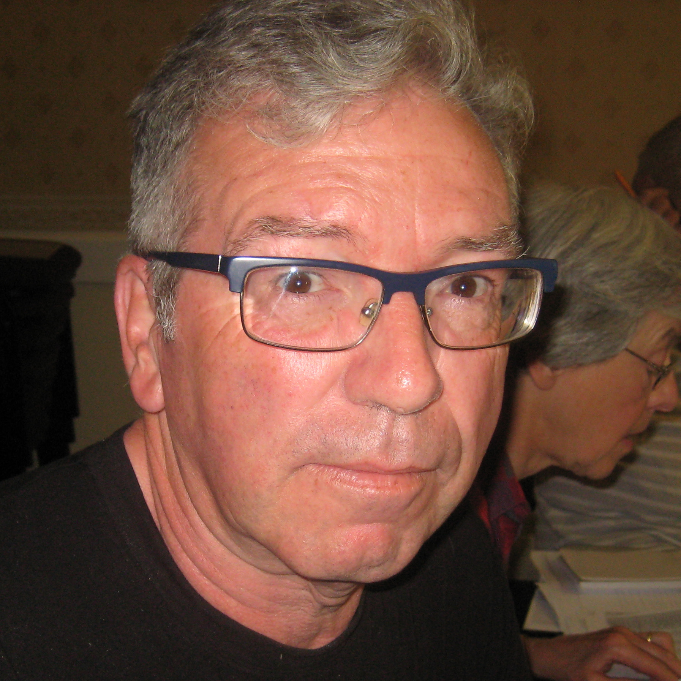

PETER HIBBARD – Heritage and Tourism, Editorial Team.

Peter’s background covers many facets related to heritage conservation, including tourism and promotion, as well as management of voluntary organisations, research, writing and photographic skills.

He was trained as an urban planner and urban sociologist at Cardiff and Birmingham Universities and briefly worked in Harrow planning department before undertaking various projects, including a study of the tourism potential of UK rural enterprises, at Bournemouth University’s Tourism and Heritage Conservation Department. Peter then became a visiting scholar at the Centre of Asian Studies, Hong Kong University (1985-1986) where he began his journey into Mainland China – where he largely resided until 2013.

In 2001 he established his company - The Ginger Griffin to raise awareness, understanding and appreciation of Shanghai’s unique historical inheritance. Peter has published extensively, been involved with major restoration projects and was awarded an MBE for his services to heritage conservation to the city of Shanghai in 2010. Peter would now like to transfer these objectives to Holmfirth.

SARAH WHITELAW – Sponsorship & Grant applications, Press Officer

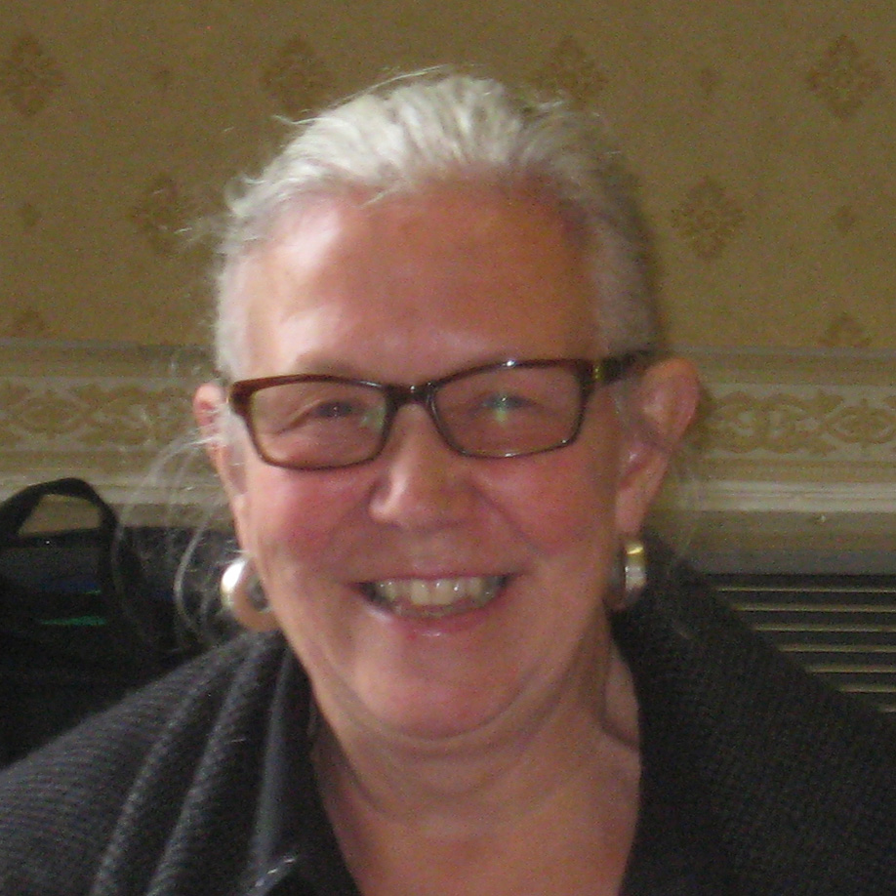

Although Sarah was brought up in East Yorkshire and Wakefield, and has lived in London and Leicestershire as well as Huddersfield, she has been a Holmfirth resident for over twenty years. She is delighted that this unique and vibrant community is now her home.

Having worked as a teacher in Huddersfield, lecturer at the University of Leeds and latterly at the Dept. for Education in Manchester, Sarah has been heavily involved in a variety of 'Community Activities'. Currently she is secretary for the Holmfirth Film Festival and is actively involved in local and national politics.

Sarah is a member of the HCG Management committee, currently working on communications and fundraising, in collaboration with the rest of the committee.



SPEPHEN BAGGOTT - Parish Council Representative, Governance

Stephen migrated to the Holme Valley from the deep south (Hampshire) in 2000 for work. Having now retired, He stayed; probably for the same reasons that all of us have in choosing to live in the Holme Valley. Stephen has lived in Honley for the last 14 years.

Stephen’s professional background is in delivering IT projects and managing the resultant organisational changes.

He became a member of the Holme Valley Parish Council in 2015 and also serves on the committee of the Honley Business association.

CLEM BACON Co-opted member. Webmaster, Data Management

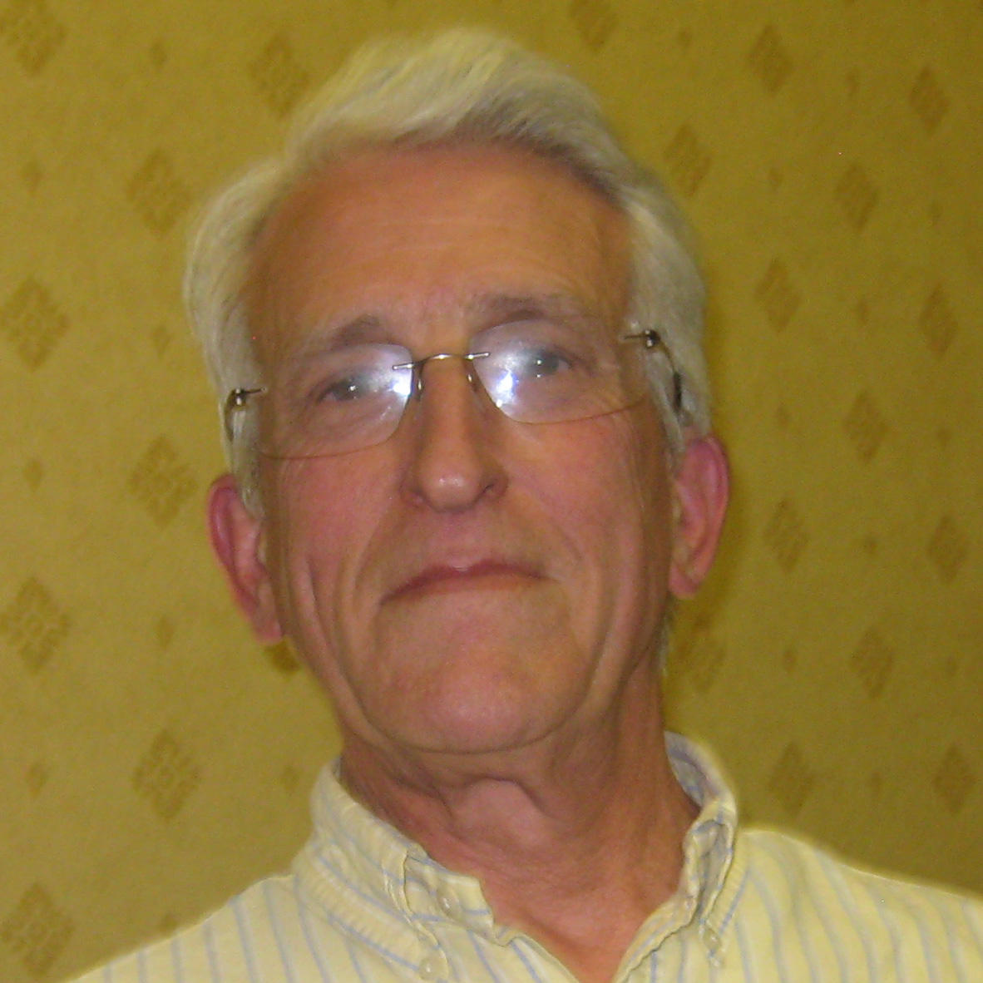

Following a brief career in the paint industry Clem pursued a career in retail, firstly as China & Glass Buyer with the Army & Navy Sores Group (now House of Frazer) An additional responsibility was as fire warden which in the case of a fire (or practice) necessitated walking round the store wearing a “Fire Warden” tin hat and waving a football rattle to encourage evacuation! Clem subsequently joined BHS working the clothing division before joining the GUS Merchandise Corporation where he developed inventory and forecasting management systems before being appointed Merchandise Director

Clem loves living in Holmfirth and is an enthusiastic supporter of community projects.

STEPHEN RANSBY – Adviser for Built Environment and Public Realm

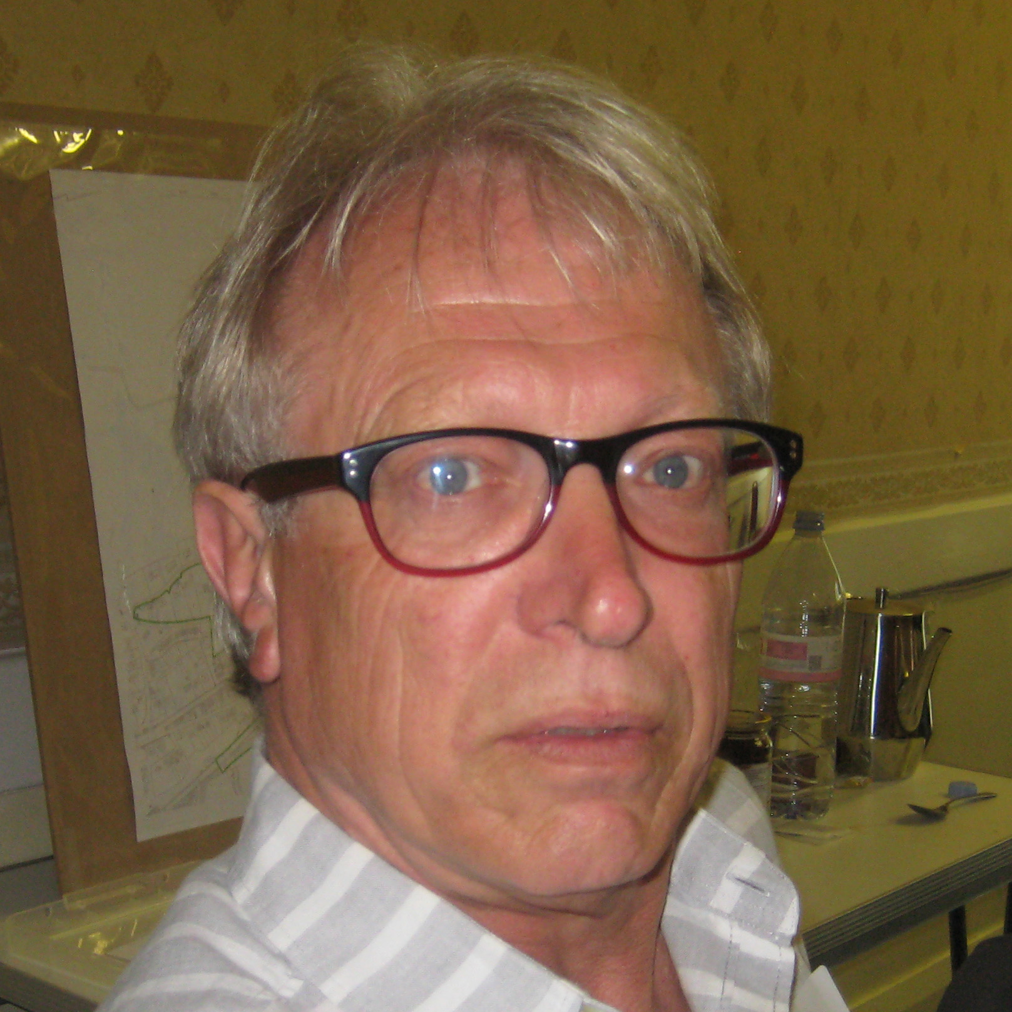

Stephen moved to Yorkshire in 1969 when he started work as a student planner with the old West Riding County Council. He lived in Barnsley and Huddersfield, before moving to Holmfirth 40 years ago.

He moved from WRCC to Huddersfield County Borough, then onto Kirklees Council. At Kirklees Stephen was Senior Planner in the Conservation Section involved in the preparation and implementation of policy.

In the late 1980’s Stephen joined Manchester Airport as a strategic planner, later to become the Airport’s Community Relations Manager.

He had the chance to work locally in the late 90’s and he has worked with several local businesses over the last 17 years. His experiences ranged from an Internet based company importing and retailing African herbal medicines to the food and drink service industry.

His non-work activities have included playing cricket for Cartworth Moor Cricket Club, school governor (including a number of years as Chairman) at Wooldale Junior School, an adult literacy tutor, fell walking and Planning Advisor and Board Member of The Sadeh Lok Housing Association when it was first established in 1988.

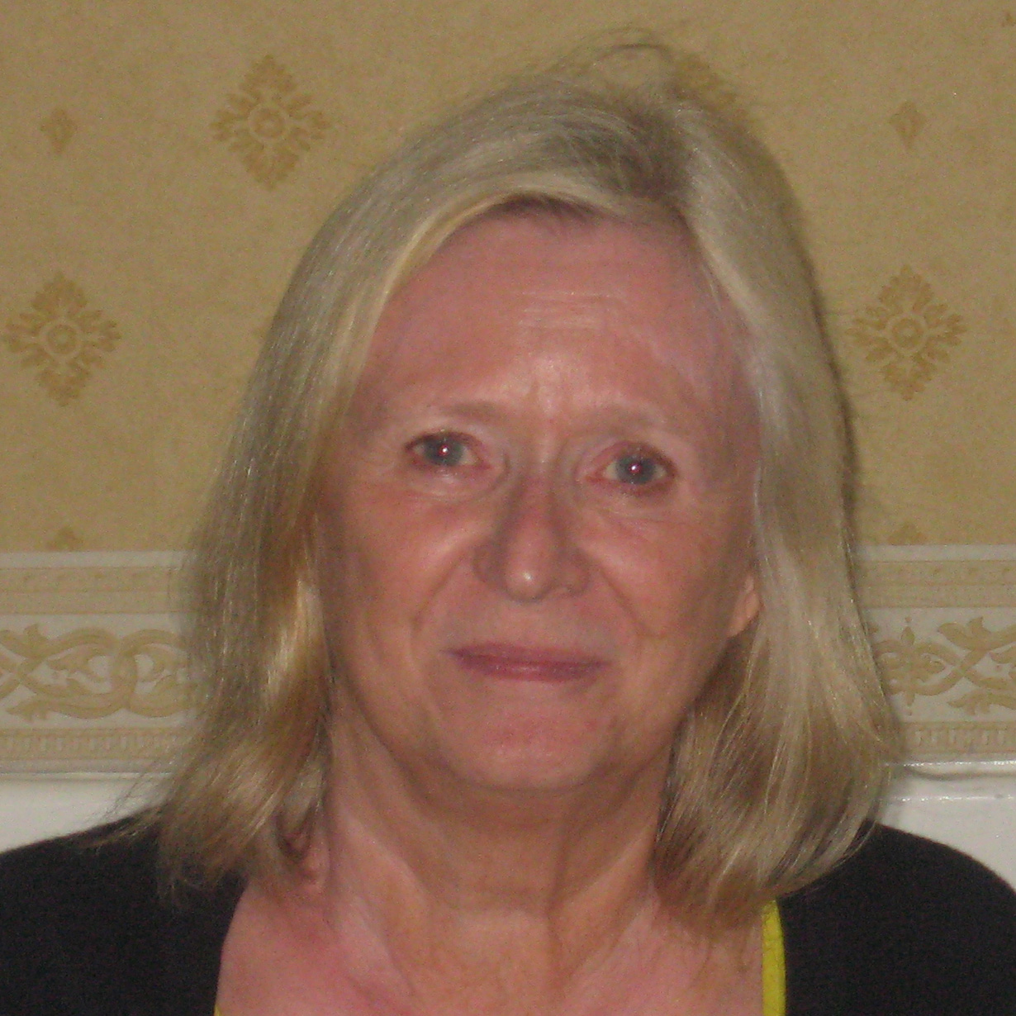

KIM CHANDLER – Events Organiser. Kim moved from Lancashire, via Dorset, to arrive in Meltham in the memorably snowy winter of 1979, with three small children. The weather, an unfinished new property and the promise of a phone line ‘hopefully in 9 months’ prompted a response of ‘I’ll stay for a couple of years’! Nearly 37 years later, after 24 in Holmfirth, the valley has worked its magic.

Once the children were all at school, she trained as a teacher at the former Bretton Hall College, where a lecturer, historian Cyril Pearce, sparked her interest in local history. She taught across Kirklees, finishing her teaching career at Thurstonland Endowed First School, where she was a governor.

A keen reader, gardener, walker, cinema goer and granny to seven, since retirement she now has time to more fully explore the Holme Valley with Brillo, her Lakeland terrier and to become more involved in its activities.

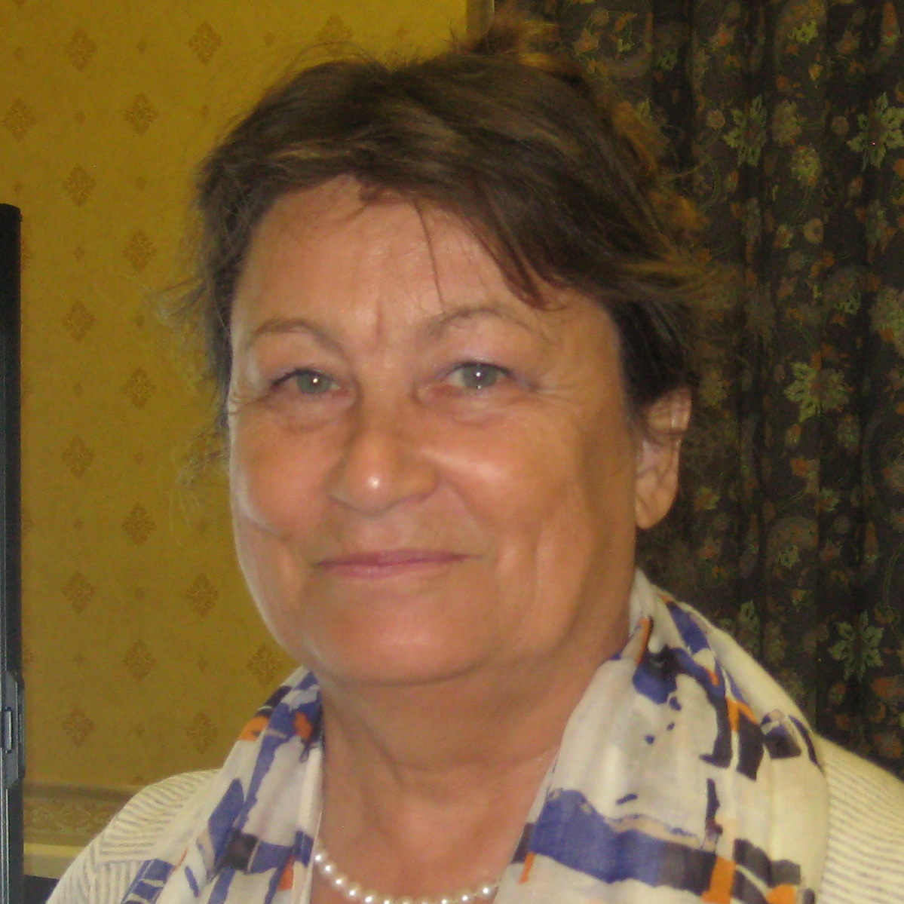

FRANCES BENNETT – Chair of Editing Team